Area of Study 3
Practical investigation

Survival requires control and regulation of factors within an individual and often outside the individual. In this area of study students design and conduct a practical investigation into the survival of an individual or a species.

On completion of this unit the student should be able to design and undertake an investigation related to the survival of an organism or species, and draw conclusions based on evidence from collected data.

A logbook (record folder) of all development work, research and raw data collection and presentation must be kept and submitted as part of the assessment for this task.

The following template is to be used by students in the development of the scientific report for the investigation undertaken.

Final Report Section Content

Title: Question under investigation is the title

Introduction: Explanation or reason for undertaking the investigation, including a clear aim, a hypothesis and/or prediction and relevant background biological concepts

Methodology: Summary that outlines the methodology used in the investigation and is authenticated by logbook entries. Identification and management of relevant risks, including the relevant safety and ethical guidelines followed in the investigation.

Results: Presentation of collected data/evidence in appropriate format to illustrate trends, patterns and/or relationships.

Discussion: Analysis and evaluation of data. Support for Hypothesis. Identification of outliers or unexpected data and their subsequent treatment. Linking of results to relevant biological concepts. Identification of limitations in method, and suggested improvements.

Conclusion: Conclusion that provides a response to the research question or aim.

References and acknowledgments: Referencing and acknowledgment of all quotations and sourced content.

Assessment Rubric Over Page

Biology Unit 1 (Area of Study 3) “Student Practical Investigation”
Assessment Rubric
 | 1 (2)* | 2 (4)* | 3 (6)* | 4 (8)* | - (10)*
*Log Book Topic Research
*Introduction Development (rough: log)
Method Development (rough: log)
Results Collection & Presentation (rough: log)
Total /30
Final Report
*Introduction
Inc’ Aim/V/H
(200 words)
Methodology
(150 words plus diagrams)

Results Presentation

*Discussion
(300 - 400 words)

Conclusion
(150 words)

References / Bibliography

Total /40

Overall Total /70 |  | Grade:  ________% | S / N
Comments

Log Book Research Task on “The Factors Effecting Photosynthetic Rate” (10 Marks)

A typical leaf cross section (dicot) diagram.
Label some Chloroplasts on this diagram.
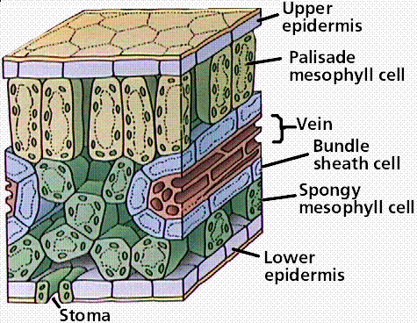
A light microscope image of a prepared dicot leaf cross section
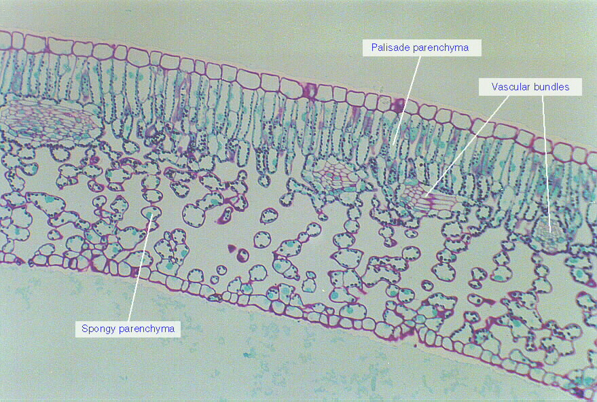
- Describe leaf structure and the way in which the reactants for photosynthesis (H₂O and CO₂) make it into photosynthetic cells.

- Label the following leaf cross section diagram. Label some Chloroplasts
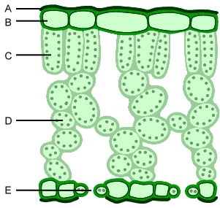

- Draw your own diagram of the above leaf structure and indicate the direction of net gas movement (O₂ and CO₂) when a plant is undergoing photosynthesis.

Chloroplasts are the site of Photosynthesis in Plants.
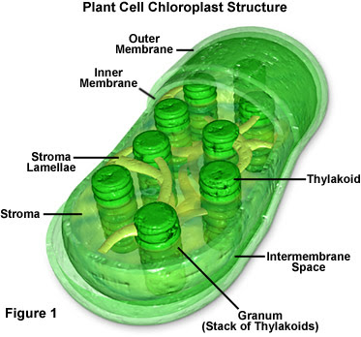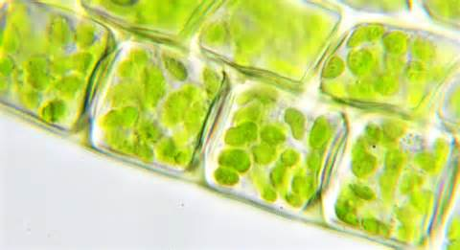

Photosynthesis Overview Diagram.
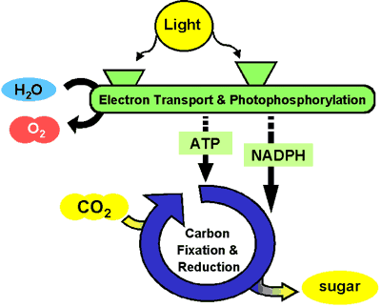
- Write the word and symbol equation for Photosynthesis below.

- What are the two phases (stages) of Photosynthesis called?

- What phase (part) of Photosynthesis does this diagram represent?
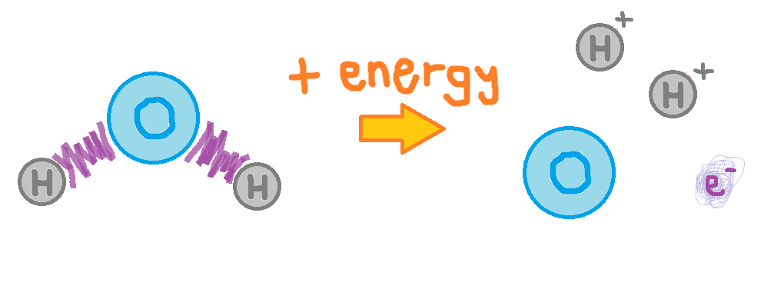
- Indicate where this process takes place on the chloroplast diagram below.

- What phase (part) of Photosynthesis does this diagram represent?
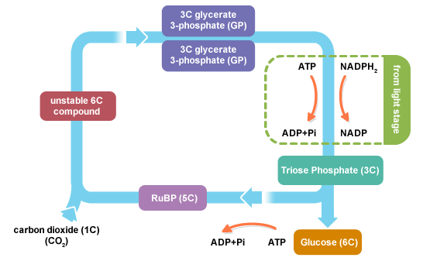

- Indicate where this process takes place on the chloroplast diagram below. Label major parts.

Factors Effecting Photosynthetic Rate
- What are the major variables (factors) that would influence the rate of Photosynthesis in a Plant?
a._____Water Availability______________
b._________________________________
c._________________________________

- Describe the graph below in your own words.

Carbon as a factor in Photosynthesis
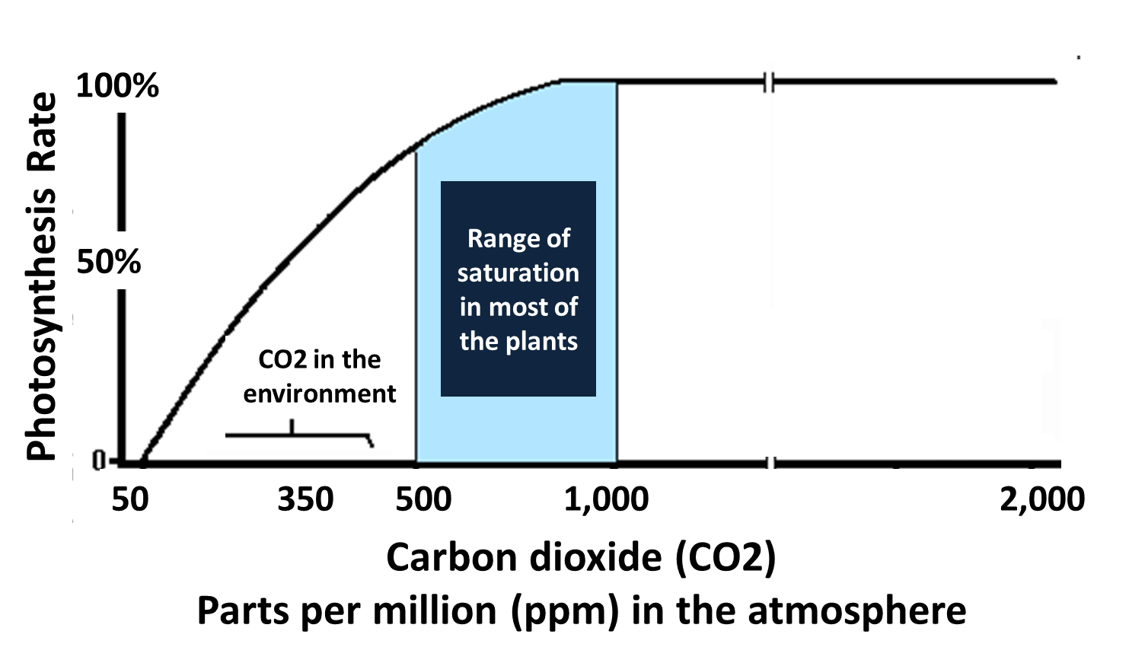

Carbon uptake as an indirect measure of Photosynthetic Rate
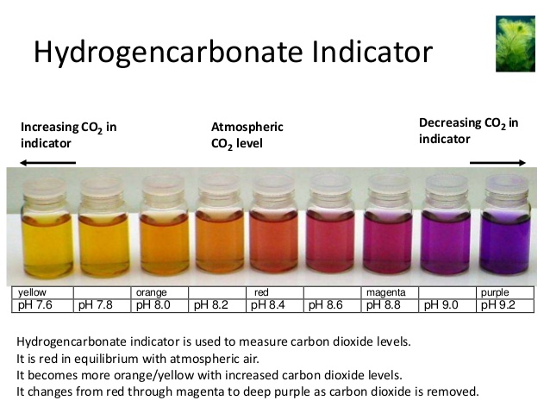
- Recall the Elodea Test Tube Experiment. Describe the indicator colours for the Elodea in sunlight and in darkness after 24 hours and link these colours to the rates of photosynthesis and levels of carbon in the different test tube solutions.

Sodium Bicarbonate (NaHCO₃) increases the available CO₂ in an aqueous (water) solution
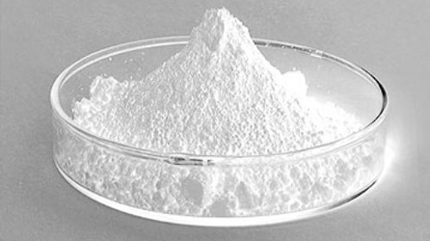
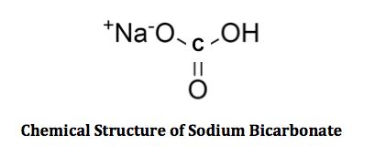
- Sodium Bicarbonate in water produces H₂CO₃ or Carbonic Acid
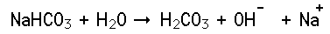

- Carbonic Acid will then release CO₂ and H₂O in an equilibrium reaction in solution
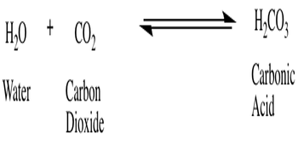
- If the amount of Carbon Dioxide decreases in a solution due to a Photosynthetic Plant, more carbonic acid will convert into CO₂ and H₂O, until no more carbonic acid remains.

- How would these changes be observed when using an indicator as shown on the previous page?

Light frequency as a Factor in Photosynthesis
- What is the picture below telling us about light absorption and light reflection in Plants?
- This image is a chromatograph of plant pigments, including Chlorophyll A and B. These protein based pigments are involved in the transfer of energy from sunlight to energy carriers like ATP and NADH+. These pigments are excited by certain wavelengths (colours) of light.

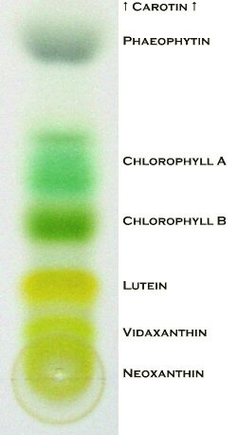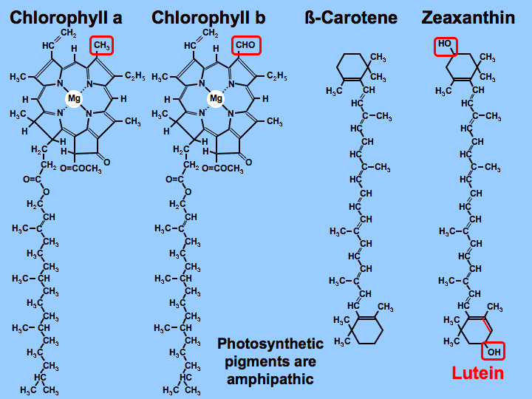

- The graph below shows the Absorbance of light frequencies by Chlorophyll A and B. The shape of these lines represents a profile for each pigment and together a profile for light absorption in plants with these pigments. Describe this profile. 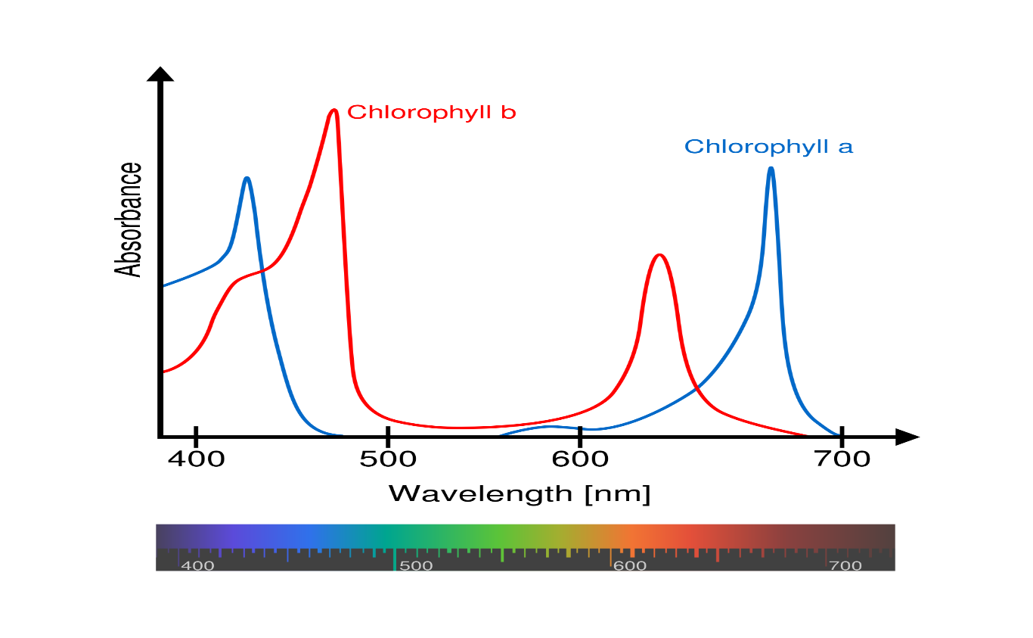
Oxygen production as an indirect measure of Photosynthetic Rate (See Below)

The Production of Oxygen in Photosynthesis
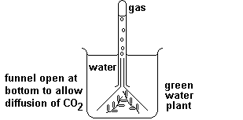
Fig. 1. Apparatus.

Method: The green water plant was first kept in the dark for several hours and then exposed to sunlight for several hours.

Observation: Before exposure no gas was produced. During the exposure a gas was produced which ignited a glowing piece of wood.

Conclusion: Exposure of the green water plant to sunlight caused oxygen to be produced.

- How would any oxygen produced in photosynthesis leave the plant?

- Briefly describe a test investigating how Carbon Dioxide levels in solution (adding sodium bicarbonate or not : IV) affect the rate of Photosynthesis (O₂ production: DV) in a plant.

- What results would you expect to find in the above Test?

- Briefly describe a test investigating how different wavelengths (colours) of light (colour filters : IV) affect the rate of Photosynthesis (O₂ production: DV) in a plant.

- What results would you expect to find in the above test?

