DNA Replication
Label each structure in this diagram.
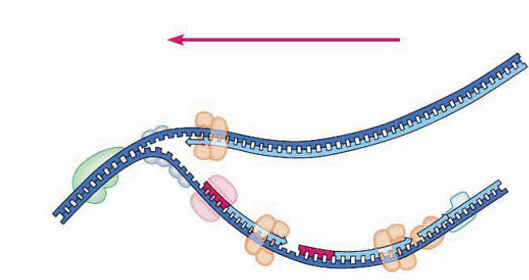

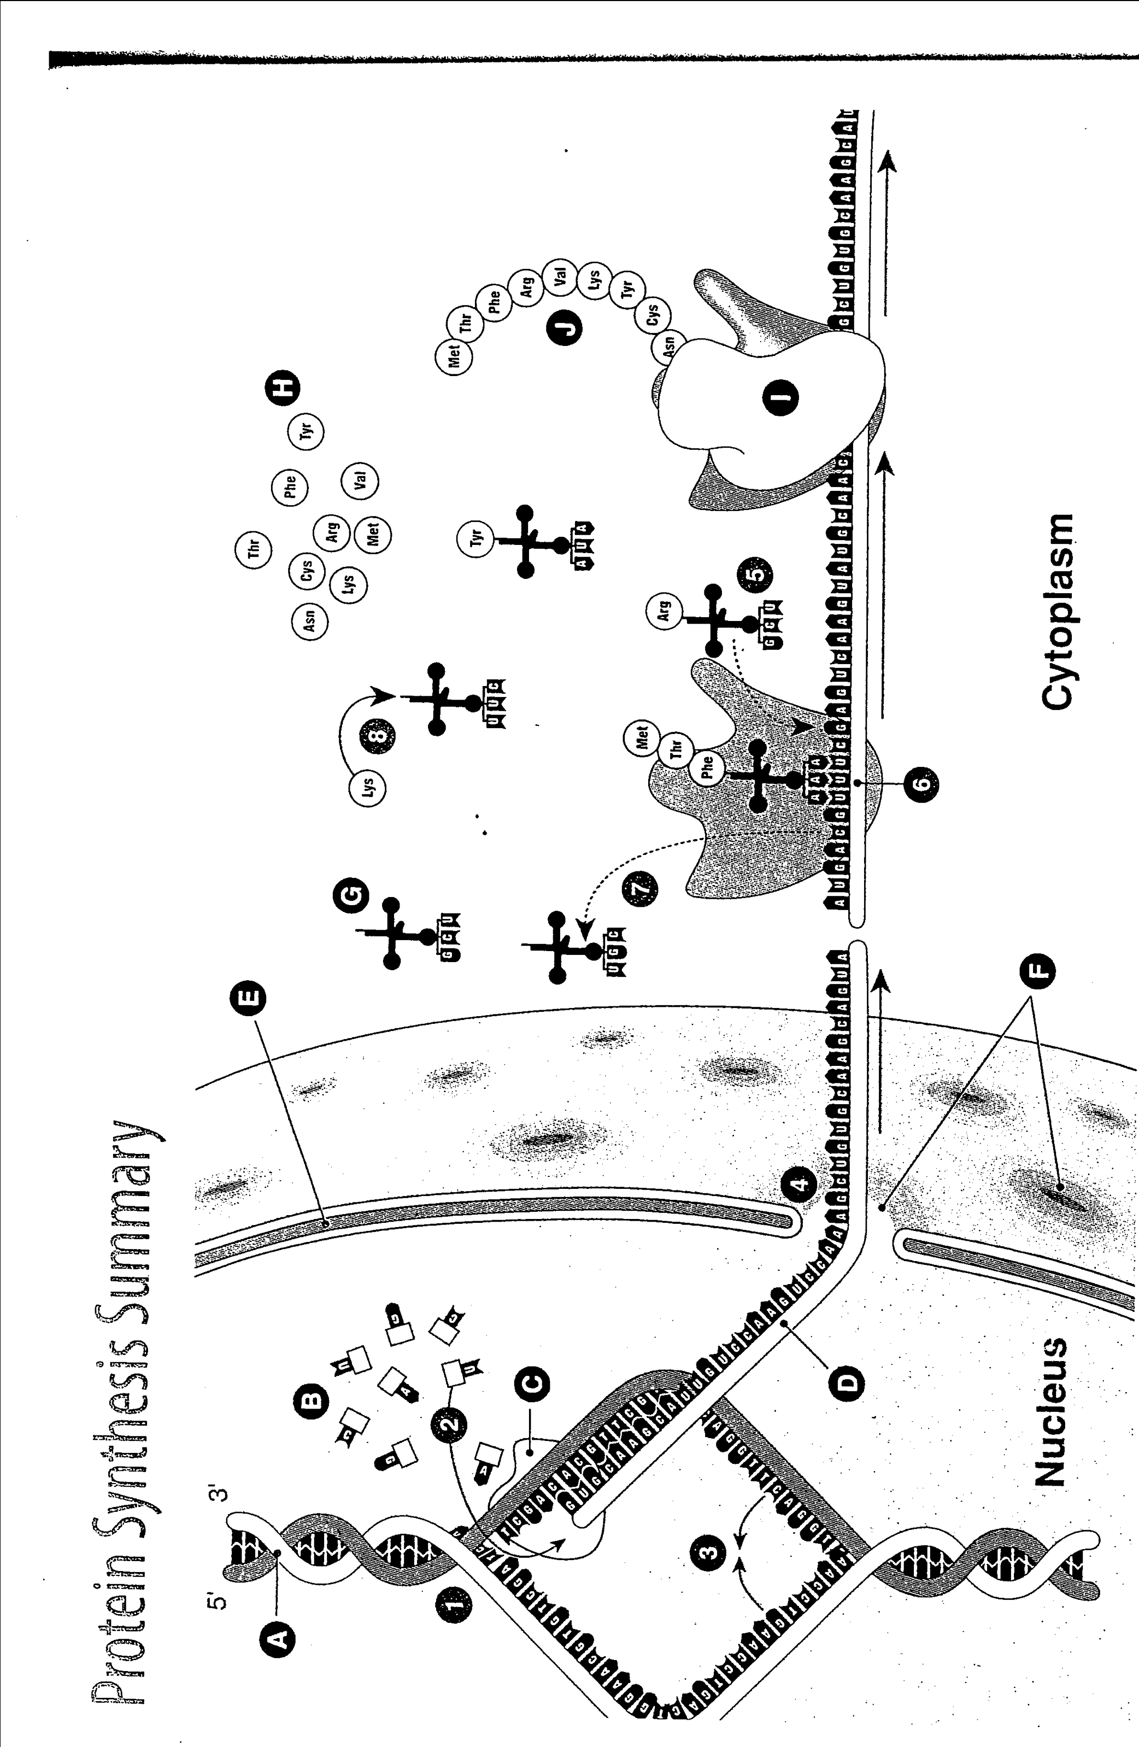
For each stage of protein synthesis (1 – 8) briefly describe what is occurring.
Label each structure (A – J): (hints) RNA polymerase, Transfer RNA molecule (tRNA), messenger RNA (mRNA), nuclear pores.
Explain what the following mean in terms of protein synthesis and highlight one on the diagram:
Codon:

Anticondon:

