Evolution
- What is a gene pool?

- What are the four forces that cause a change in a gene pool?

- What is gene flow?

- What are the two types of gene flow?

- What happens if genetic drift has occurred

- What is a bottleneck effect?

- Name one way in which a bottleneck effect would occur

- What is founder effect?

- What defines something as a new species?

- What is natural selection?

- What is speciation?

- What causes allopatric speciation?

- What is symbiotic speciation?

- What are the reasons for allopatric speciation?

- What are the following diagrams showing

- 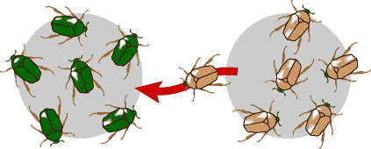
- 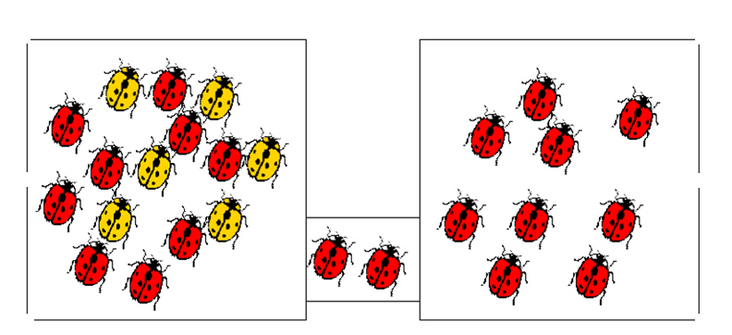
- 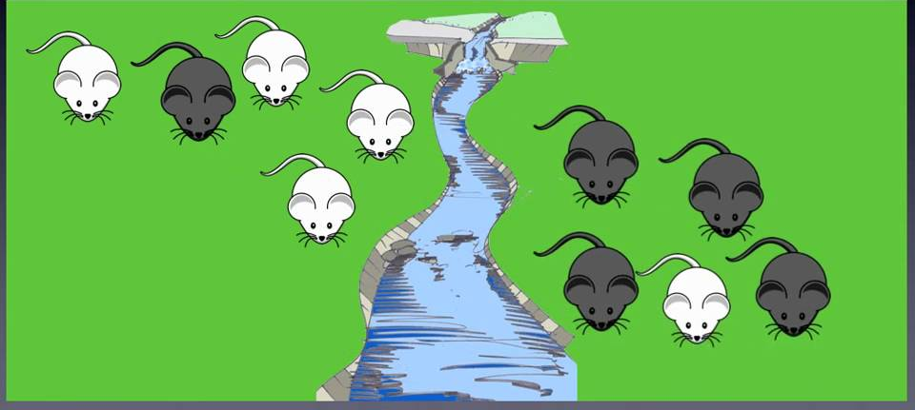
- 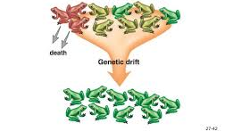

- What post-reproductive isolating mechanisms of speciation?

- What are some reproductive isolation mechanisms?

- What is a homologous structure and what do we know from these structures?

- What does an emu, ostrich and kiwi have in common and how do you know?

- What is a phylogenetic tree?

- What does this tree show you?

