Molecular Biology

The emergence of new molecular biology technologies have resulted in significant advancements in the way we detect and treat diseases
- Karyotyping (pre-natal), gel elctrophoresis (pre-symptomatic) and DNA microarrays can all be used to confirm a medical diagnosis
- Rational drug design can be used to create specific treatment molecules for a range of conditions

In addition, some of the other new technologies being developed include:

Anti-Drug Vaccines
- A fragment of the drug molecule is made into a vaccine, such that the body produces specific antibodies for the drug
- While the antibodies do not destroy the drug, by forming a complex with the drug it becomes to large to cross the blood-brain barrier
- As a result the drug can no longer work as intended, eliminating the addictive effects of drugs such as nicotine, cocaine and heroin

Manufacturing Biomolecules
- Disorders arising from the absence of a necessary enzyme or protein can be treated with continued injections of the required biomolecule (e.g. IDDM)
- Using recombinant DNA technologies, such biomolecules can now be mass produced by bacterial colonies (e.g. insulin, monoclonal antibodies)
- Animal hybrids are also being developed to produce human forms of proteins (e.g. insulin in cow's milk, pigs with human skin for xenotransplants)

Treating Haemophilia via the Isolation of Human Factor IX Clotting Protein from Transgenic Sheep Milk
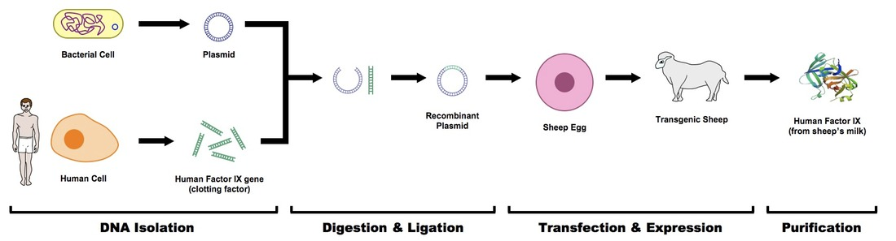

Nanoparticle Drug Delivery
- Under current treatments, drugs circulate the body to reach their destination and can potentially damage normal cells in the process
- Nanotechnology is being used to develop nanoparticles that can be directed to certain cell types and is being used in the treatment of cancer
- Rapidly dividing cells (like cancers) need folic acid and produce ~1000 times more folate receptors on their cell surface
- Combining a cancer treatment with folate as part of a nanoparticle may provide an effective treatment for certain types of cancer

Gene Therapy
- Gene therapy is an experimental treatment that involves introducing genetic material into a person’s cells to fight disease
- The process involves identifying genetic mutations which cause disease and inserting corrective copies into the patient’s cells
- The main difficulties encountered with this nascent technology involve:
  - Finding efficient ways to deliver genes to the body
  - Finding ways to have these genes being consistently expressed

Antisense Technology
- Antisense therapy is a procedure being designed to treat disorders caused by the expression of incorrectly folded or harmful proteins
- Protein expression is dependent on the production of mRNA transcripts, which are always single stranded
- It has been discovered that double stranded mRNA is destroyed by host cell machinery
- Antisense therapy aims to introduce complementary mRNA sequences and thus prevent protein expression

Preventing Translation of a Specific Polypeptide via Antisense Technology
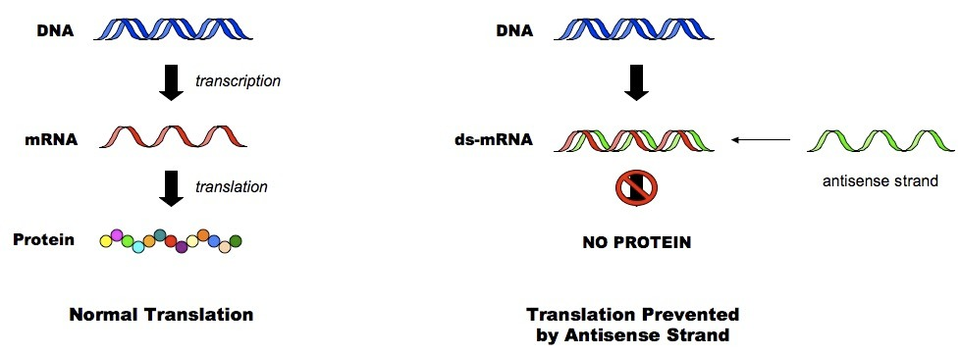

Pharmacogenetics
- Pharmacogenetics involves studying and clinically identifying genetic variations that gives rise to differing response to drugs
- Different individuals will respond to drug treatments differently because of polymorphisms in their gene and protein sequences
- Pharmacogenetics aims to identify these differences and, by doing so, design and optimize drug treatments to suit individuals

Drug Design
Drugs work by interacting with target molecules in our body and altering their activity in a way that is beneficial to our health
A drug may function by either stimulating the activity of its target (agonists) or by blocking or inhibiting the activity of its target (antagonists)

Rational Drug Design
Rational drug design involves determining the structure and function of a target molecule and using this information to develop effective drug treatments
It involves the following steps:
- Disease conditions are researched to identify specific biological target molecules - as these molecules are usually proteins, this involves proteomics
- Structural information is determined using methods such as X-ray crystallography or nuclear magnetic resonance (NMR) imaging
- Online databases are referenced to identify chemical compounds most likely to interact favourably with the desired target molecule
- Treatment compounds can then be developed using molecular modelling software designed to optimise and improve the identified chemical analogs
- The designed drug can then be synthesised (using combinatorial chemistry) and tested in animal and clinical trials to determine its therapeutic value
- Some of the drugs designed by this process include Relenza (for influenza), Indanivir (for HIV), Gleevec (for leukemia) and Viagra

Relenza
One of the first drugs produced by rational drug design was Relenza, which was designed to treat the spread of infection of the influenza virus
- Relenza was developed by identifying molecules most likely to interact with neuraminidase
- Neuraminidase is a virus-produced enzyme that is needed to release newly formed virions from an infected cell
- It cleaves the haemagglutinin glycoprotein which anchors the virion to the infected cell's surface, thereby mediating its release
- By blocking the active site of neuraminidase (i.e. competitive inhibition), Relenza inhibits the spread of infection

Overview of the Treatment of Influenza by Relenza
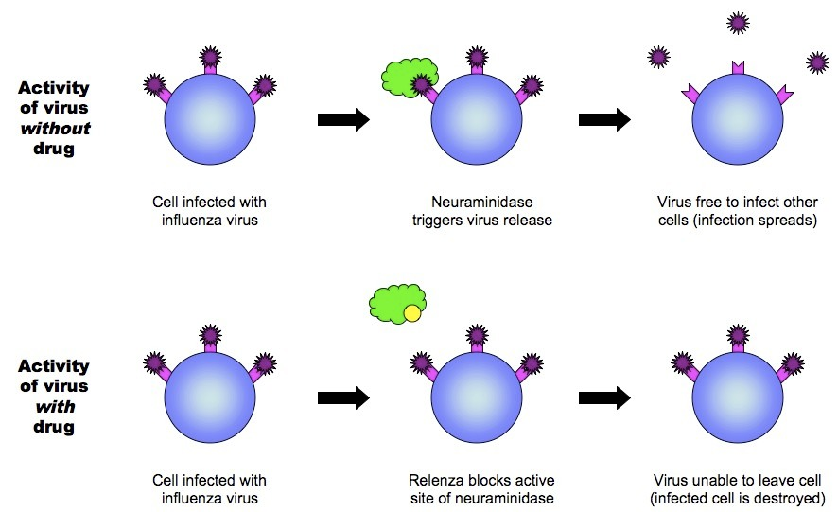

Medical Diagnosis
Diagnostic screening allows medical practitioners to identify diseases caused by defective chromosomes, genes or proteins
This screening can occur pre-natally (before birth), pre-symptomatically (before symptoms develop) or be used to confirm a suspected diagnosis

Karyotyping
- A karyotype is a visual profile of all the chromosomes in a cell
- The chromosomes are arranged into homologous pairs and displayed according to their structural characteristics
- Pre-natal karyotyping is often used to test for chromosomal abnormalities (e.g. aneuploidies resulting from non-disjunction)

Human Male Karyotype
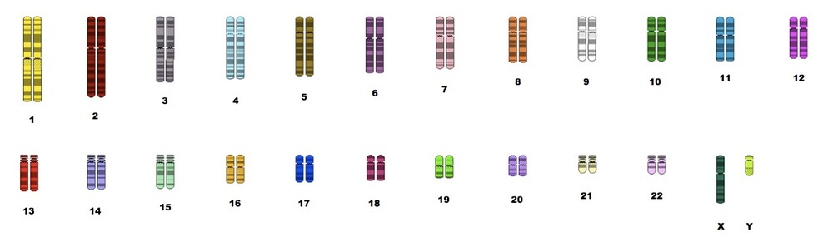

Karyotyping involves:
- Harvesting cells (usually from foetus or white blood cells of adults)
- Chemically inducing cell division, then halting it during mitosis when chromosomes are condensed and thus visible
  - The stage during which mitosis is halted will determine whether chromosomes appear with sister chromatids
- Staining and photographing chromosomes, before arranging them according to structure

Gel Electrophoresis
Gel electrophoresis is a technique which is used to separate fragments of DNA according to size
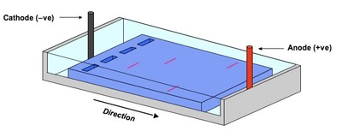
- Samples of fragmented DNA are placed in the wells of an agarose gel
- The gel is placed in a buffering solution and an electrical current is passed across the gel
- DNA, being negatively charged (due to phosphate), moves to the positive terminus (anode)
- Smaller fragments are less impeded by the gel matrix and move faster through the gel
- The fragments are thus separated according to size
- Different alleles will be different sizes and thus be used to identify genotypes and carriers
- Disorders like Huntington's disease, which is late onset and caused by a trinucleotide CAG repeat, can be resolved by gel electrophoresis before symptoms appear

DNA Microarrays
- Genetic disorders can be screened using a DNA microarray - a collection DNA spots / probes (representing genes) embedded on a solid matrix
- A single microarray can contain 10,000 or more probes and can hold representative fragments from the entire genome
- To determine which genes are being expressed by cells (including those responsible for disease), the following steps are conducted:
  - mRNA from the cell is converted into copy DNA fragments (cDNA) by the enzyme reverse transcriptase
  - The cDNA fragments are attached to a fluorescent dye and added to the microarray
  - cDNA fragments will bind to their specific probe (via complementary base pairing) and remain fixed when unattached fragments are washed away
  - The wells that still fluoresce after washing contain fragments that represent mRNA being expressed within the cell
  - Comparing the genes being expressed in a normal individual versus a sick individual can provide clues as to the cause of disease

Overview of DNA Microarrays
