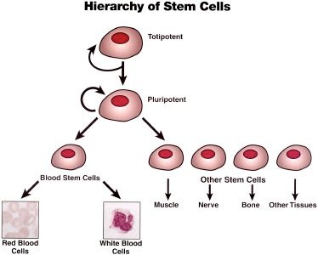

 | Description/Characteristics | Sources
Embryonic Stem Cells
Adult Stem Cells

Sources of Adult Stem Cells, the Types of Stem Cells and the possible uses for these cells

