LIVING IN THE ENVIRONMENT

Nelson: 199 - 200
Biozone: 230
Environmental factors are identified as being biotic or abiotic. Define these terms.
Biotic factors are factors that relate to the effect of one living organism upon others.
Abiotic factors are the physical and chemical factors in an ecosystem

Observe the diagram below. Identify the biotic and abiotic factors that would affect this ecosystem.

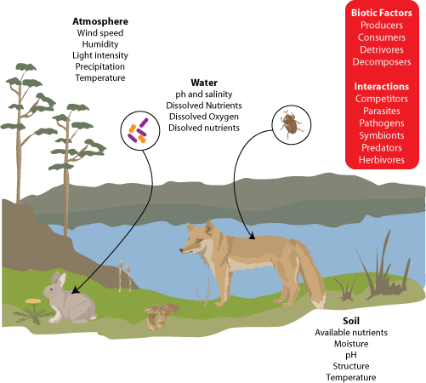

TOLERANCE
Nelson: 200 - 202
Biozone:

What does the term tolerance range mean?
For each factor that affects living organisms there is a range of conditions where the organism functions best.

Observe the diagram below
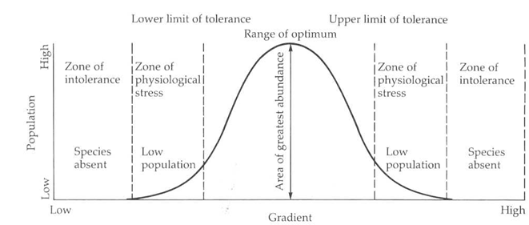

What happens to an organism if conditions are outside the optimum range?
It begins to suffer physiological stress and functioning is impaired.

Can an animal survive in the zone of physiological stress? Explain.
Yes they can survive, being exposed to these conditions for longer periods of time decreases their ability to survive.

Describe how population numbers alter as conditions change from optimum to the zone of physiological stress, to the zone of intolerance. Why do these changes occur?
Population numbers are at the maximum in optimum conditions, they decrease in the zone of physiological stress and eventually fall to zero in the zone of intolerance. The change in numbers occur because conditions start of as being favourable and gradually decrease to a point where organisms are no longer able to survive.

GEOGRAPHIC DISTRIBUTION
Nelson: 202-203
Biozone:

Define the term geographic distribution
Geographic distribution refers to the arrangement of populations of organisms in specific areas.

What factors affect geographic distribution?
All biotic and abiotic factors will affect geographic distribution. A species tolerance range also impacts its distribution; the greater the tolerance range, the wider the distribution.

ECOSYSTEMS
Nelson: 203 – 205
Biozone:

Define the term ecosystem
Ecosystems are self-sustaining units made up of living organisms interacting with the physical environment.

Ecosystems are frequently named based upon the type and amount of vegetation present.
Define the following terms:

TERM | DEFINITION
Woodland | Canopy is widely spaced; 10 to 30%
Forest | Trees are taller than 6m, canopy is greater than 30%
Shrub land | The plants present are shorter than 5m. Shrubs are woody plants with many stems.
Grassland | Grassland are areas dominated by grasses, with few if any shrubs or trees.
Open | Coverage is between 30 and 70%
Closed | Coverage is between 70 and 100%

Ecosystems are monitored in order to determine their viability and sustainability. Environmental factors are studied individually and collectively as they all interact. Information gained from these studies is used to make vital decisions for the future. Complete the table below explaining the significance of measuring each type of factor:

FACTOR | MEASURED BY | SIGNIFICANCE
Salinity | Salinity meter | The majority of plants cannot grow in saline conditions. If salinity goes unchecked it can lead to other problems such as erosion.
Light | Light meter | Light intensity will affect the rate of photosynthesis. The availability of light can also affect the ability of predators to detect prey and for organisms to camouflage themselves.
Dissolved oxygen | Biological oxygen demand | Organisms require oxygen for cellular respiration. Soil or waterways with less dissolved oxygen can’t support as many organisms.
Turbidity | Secchi disk | Turbidity of water affects the amount of light that can reach the plants growing in the water. Plants are the first stage in the majority of food chains. So if there are less plants present then there will also be less organisms.
Rainfall | Rain gauge | Water availability will determine the number of plants and animals that can be supported by an ecosystem.
Temperature fluctuations | Thermometer | Temperature affects a number of abiotic factors such as the amount of dissolved gases. It will also affect an organism’s rate of cellular respiration and behaviour.
Humidity | Hygrometer | Humidity affects the amount of water loss from plants (transpiration). Plants lose less water in humid environments. The amount of water vapour in the air will influence temperature as water vapour absorbs infrared radiation.

What term is used to describe diagrams such as the one below?

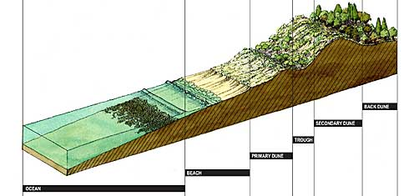

Transect

Is the following diagram showing stratification or zonation? Explain

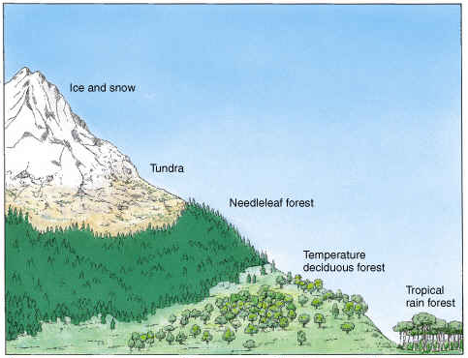

Zonation. The difference in abiotic conditions has given rise to distinct zones that are different ecosystems.

Is the following diagram showing stratification or zonation? Explain

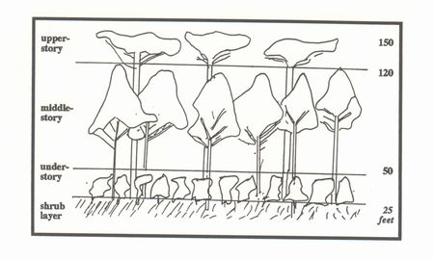
Stratification. This picture shows a single ecosystem. The plants in the ecosystem are of different heights creating different strata.

HOMEOSTASIS
Nelson: 233-234
Biozone: NA

Define the term homeostasis
Homeostasis is the maintenance of a relatively stable internal environment despite external fluctuations.

Why is homeostasis important?
Homeostasis is important as it enables organisms to return to optimum conditions, lessening the period of time that physiological stress is experienced.

What is the external environment for a single celled organism?
The environment outside the cell (the actual external environment)

What is the external environment for the majority of cells in a multicellular organism?
The interstitial or extracellular environment.

Identify 2 ways in which a single celled organism can respond to a change in the external environment
Move away or die.

Identify the 2 systems which are the most responsible for maintaining internal stability in humans.
Nervous and hormonal systems

FEEDBACK
Nelson: 235-236
Biozone: NA

Feedback is a response which either reinforces or counteracts the stimulus.

Define the term negative feedback
The feedback is in the opposite direction to the stimulus.

Define the term positive feedback
The feedback is in the same direction as the stimulus.

A person who has a low level of water in their blood reabsorbs more water resulting in an increase in blood water levels. Is this an example of negative feedback or positive feedback? Explain.

Negative feedback. Initially blood water levels were lower than normal. As a result of the response the blood water levels have increased, moving closer to normal.

Feedback mechanisms (also represented as stimulus/response diagrams) have 5 major components. Define each of the components in a feedback mechanism.

COMPONENT | DEFINITION
Stimulus | A change that occurs that will initiate a response.
Receptor | A structure that detects change.
Control Centre | Part of the body that receives the signal and sends out a message to an effector
Effector | A part of the body that carries out the response.
Response | This happens as a result of the actions of an effector.

Describe what happens in a feedback response beginning with the stimulus and finishing with the response.

- A change (stimulus) occurs
- Production of a signal when a change occurs
- Detection of the signal by a receptor
- Signal transduction (transfer) to the target tissue
- Response by the target tissue

RECEPTORS AND VARIABLES
Nelson: 241
Biozone: NA
Stimuli are changes to the external or internal environment. Identify eight conditions that are monitored and need to be kept stable

1 | Internal body temperature
2 | Blood glucose concentration
3 | Blood water concentration
4 | Internal pH
5 | Concentration of ions such as calcium, sodium and potassium
6 | Light
7 | Respiratory gases
8 | Nutrients

The table below identifies the main types of receptors. Complete the table identifying where these receptors are located and the role that they play.

RECEPTOR TYPE | LOCATION | ROLE
Chemoreceptor | Located in major arteries, taste buds and in the brain | Detect chemical changes
Mechanoreceptor | Located in joints, ears and lungs | Stimulated by forces that change the shape of sensory nerve endings e.g. sound, touch or pressure.
Photoreceptor | Eyes | Stimulated by light.
Thermoreceptor | Located in the skin and brain. | Stimulated by temperature changes. Regulation of internal body temperature.
Pain receptor | Nerve endings in the skin | Minimises the body’s exposure to painful stimuli.

NERVOUS SYSTEM
Nelson: 237 - 241
Biozone: 255 - 256

What are the 2 sub-divisions of the nervous system?
Central and peripheral nervous systems.

The functional unit of the nervous system is the neuron.

Identify the components of a neuron on the diagram below.

Structures shown on this diagram include: Axon, Cell body, Cell membrane, Dendrites, Myelin sheath, node of Ranvier, Nucleus, Pre synaptic terminal
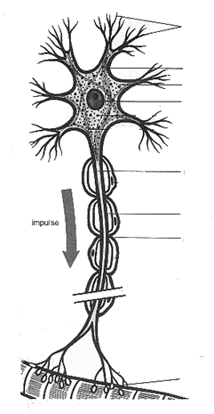
Myelin sheath
Node of Ranvier
Axon
Cell membrane
Pre-synaptic terminal
Cell body
Dendrites

Explain the role of each of these components in a neuron.

COMPONENT | FUNCTION
Dendrite | Receives information
Pre synaptic terminal | Releases neurotransmitters into the synapse
Post synaptic terminal | Receives neurotransmitters from the previous neuron
Myelin sheath | Provides electrical insulation, maintaining the efficiency of the nervous impulse.
Axon | Long extension of a neuron by which the cell sends information to target cells

What is the direction of impulse transmission in a neuron?
In through the dendrites, along the axon to the presynaptic terminal.

There are 3 main types of nerves. Fill in the boxes, identifying the type of neuron shown and an explanation as to how you can tell.

Neuron 1
This is a sensory neuron. Receptors in the skin indicate that this nerve is involved in detection. The lateral cell body also identifies this as a motor neuron.
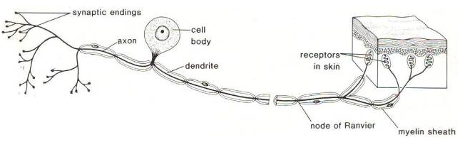

What is the function of neuron 1?
To detect changes and transmit impulses from receptors to the CNS

Neuron 2
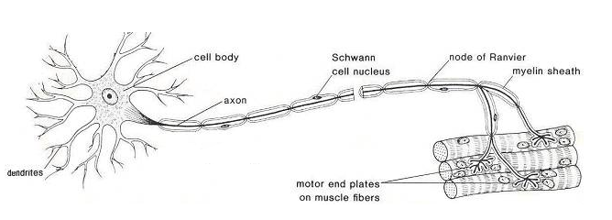
This is a motor neuron. This neuron is connected to muscle fibres (effectors)

What is the function of neuron 2?
These have many extensions called dendrites that receive signals from other neurons and a single axon that transmits signals from the CNS to other neurons, muscles or glands.

Neuron 3
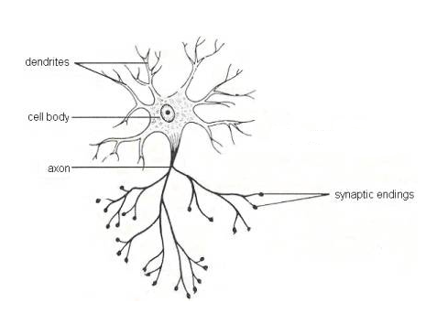
This is an interneuron. It has a very short axon and is not myelinated.
What is the function of neuron 3?

These are located in CNS and transmit nervous impulses between neurons in the CNS

Nervous responses are said to be “all or nothing” what does this mean?
A response either occurs or it doesn’t.

The stimulus must reach a threshold level for a response to occur. What does this mean?
The stimulus has to reach a certain level for a response to occur.

Nervous impulses are electrochemical. What does this mean?
Nervous impulses have an electrical component and a chemical component.

Briefly explain how an electrical impulse moves along an axon.
1) The cell membrane becomes more permeable and Ion channels for sodium in the membrane open and the sodium ions diffuse from the interstitial fluid into the cytoplasm of the axon
2) The sodium ions are positive in charge so they make the cytoplasm less negative (the resting potential of the cell decreases and it depolarises
3) If the depolarisation reaches the threshold level then an action potential is generated. If not nothing happens.
4) The sodium channels close and the potassium channels open.
5) Potassium diffuses out of the cytoplasm reducing the charge inside the cell. This is called repolarisation.
6) The potassium channels close.
7) The resting potential is restored by the sodium/potassium pump. The ions are transported back across the membrane so that the original concentration of ions is restored.

Define the term “neurotransmitter” and explain the role of neurotransmitters.
Neurotransmitters are chemicals that are released from presynaptic nerve terminals into the synaptic cleft

By diffusing across the synapse or junction, they cause the transfer of the impulse to another neuron, a muscle or some other structure.

Identify the structures shown in the diagram below

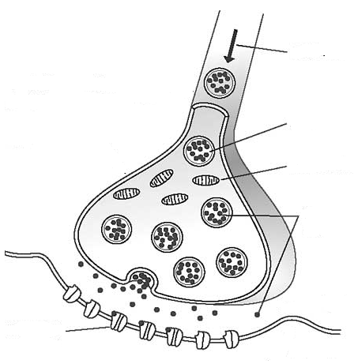
Post synaptic terminal
Secretory vesicle
Mitochondria
Neurotransmitter
Direction of impulse travel

Explain what happens when an impulse arrives at the presynaptic terminal
Calcium ions are taken up by the presynaptic terminal triggering the release of neurotransmitters into the synapse

Identify the process by which neurotransmitter crosses the synapse.
Diffusion

Explain why it is essential for the neurotransmitter to be broken down after it has crossed the synapse?
If the neurotransmitter is not broken down it will continue to trigger nervous impulses in the post synaptic terminal.

What is myelin? How does the presence of myelin affect the rate of transmission of nervous impulses?
Myelin is a fatty substance that forms a sheath surrounding the axon of a neuron. Myelin serves to increase the speed of transmission of impulses; by allowing them to jump from one unmyelinated segment to the next (this is called saltatory conduction)

Why are the nerves of organisms without myelin bigger than myelinated nerves?
Increasing the size of the nerves increases their diameter which enables impulses to be transmitted more rapidly.

Observe the diagram below. Label all of the neurons involved in this type of response.

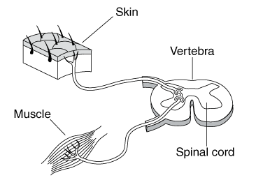
Sensory neuron
Sensory neuron
Sensory neuron

What is being shown in this diagram?
A reflex arc

What is the importance of this type of response?
Reflex arcs allow rapid responses, the exposure to a harmful stimuli is reduced which minimises harm to the body.

Draw a stimulus-response diagram for this example.

Stimulus (Pain) Receptor (Sensory nerve ending) Control centre (spinal cord) Effector (muscle) Response (limb moves away from the source of pain).

ENDOCRINE SYSTEMS
Nelson: 251 – 253
Biozone: NA

What substances are produced by endocrine glands?
Hormones

Where are these substances secreted into?
The circulatory system

What is a target cell?
A cell which has the appropriate receptor for the hormone.

Hormones are “specific”, what does this mean?
Hormones are only able to bind to receptors with a complementary shape.

Why are hormonal responses slower than nervous responses?
Nervous impulses are electrochemical. The electrical component of the impulse is very rapid. Hormones are chemical and they have to be secreted into and travel through the circulatory system before they are able to bind with their target tissue and initiate a response.

Some hormones are antagonistic, what does this mean? Provide an example of antagonistic hormones.
Antagonistic hormones have opposite effects. Insulin is responsible for decreasing blood glucose levels and glucagon is responsible for increasing blood glucose levels.

BLOOD GLUCOSE REGULATION
Nelson: NA
Biozone: NA

The two main hormones involved in blood glucose regulation are insulin and glucagon.

Draw a stimulus response diagram showing what occurs when blood glucose levels are high.

The diagram below links the events that occur when blood glucose is high or low.

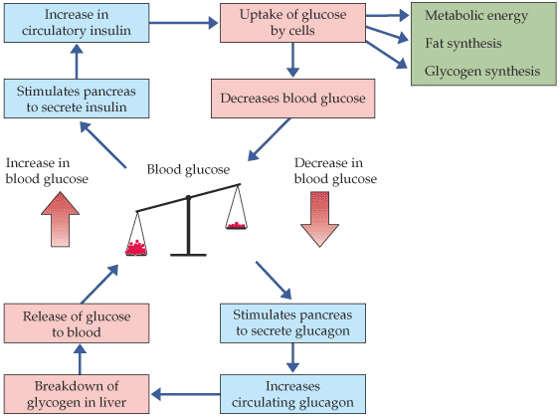

BLOOD WATER REGULATION (OSMOREGULATION)
Nelson: 261-265
Biozone: 260-263

Why is water regulation important?
A large percentage of our bodies are water. The fluid in our bodies is responsible material transport and for transporting substances around the body. Many chemical reactions occur in the fluids inside our bodies. If there are insufficient fluids the comparative concentration of solutes inside and outside of our cells is altered and many functions are affected.

Identify several ways by which an organism obtains water.
Drinking, eating and reabsorption.

Identify the hormone involved in osmoregulation.
Antidiuretic hormone (ADH)

What is the target tissue for this hormone?
The collecting tubule of nephrons.

Draw a stimulus response diagram indicating what happens when blood water concentration is too low.
Dehydration begins osmoreceptors in hypothalamus detect rise in concentration of blood solutes neurosecretory cells produce more antidiuretic hormone, which is transported to blood via posterior pituitary ADH increases permeability of nephron distal tubules and collecting ducts to water More water is reabsorbed into the blood stream from the nephron, small volumes of concentrated urine are produced.
Draw a stimulus response diagram indicating what happens when blood water concentration is too high.

Blood water concentration increases change is detected by osmoreceptors Pituitary gland secretes less ADH Collecting duct is less permeable to water Less water is reabsorbed and larger volumes of dilute urine is produced.

COMPARISON OF THE NERVOUS AND ENDOCRINE SYSTEMS
Nelson: NA
Biozone: NA

Complete the table below comparing the nervous and endocrine systems

FEATURE | NERVOUS SYSTEM | ENDOCRINE SYSTEM
Speed of the signal | Rapid | Slow
Duration of the response | Short | Long
Does it involve chemical transmission? | Yes | Yes
Does it involves electrical transmission | Yes | No
Does the strength of the response vary? | No | Yes
Where is the control centre? | Central nervous system | Variety of glands and the brain
What are the signalling molecules? | Neurotransmitters | Hormones
How do the signalling molecules reach the target tissue? | Secreted into the synapse and diffuse to the next neuron or other structure | Secreted into the circulatory system, hormones travel through the circulatory system until the target tissue is reached

THERMOREGULATION
Nelson: 253-256
Biozone: 257-259

Body temperature must be regulated in order to maintain an optimum temperature for enzyme activity. In humans, if the temperature rises above 40 degrees enzymes start to denature and if the internal temperature becomes too low metabolic activity also slows down. If either of these conditions persists it can be fatal.

Regulation of body temperature involves regulating heat exchange with the environment and controlling metabolic heat production.

Define the term ectotherm and provide an example of an ectotherm.
Ectotherms cannot produce heat internally to increase their body temperature. They are usually animals (except mammals and birds) e.g. snakes.

How do ectotherms maintain their internal temperature?
They have to rely on the external environment and they also lose heat to the environment more rapidly. They may cope with this by obtaining heat from the external environment by exposing themselves to sunlight as they can flatten out to increase their surface area. Often just prior to winter they will eat a lot of food and then hibernate. During hibernation their body temperature drops and their metabolic rate slows down. The “stored” food in their tissues is able to meet the lower metabolic demands until the external conditions warm up.

Define the term endotherm and provide an example of an endotherm.
Endotherms generate internal heat to maintain a constant body temperature.

How do endotherms maintain their internal temperature?
They may have insulating materials such as fur or feathers to slow heat loss and they also have physiological mechanisms that help regulate internal heat (core body temperature). For most animals if this is exceeded by 6 degrees or more it is often fatal. Animals tend to have structures such as fur, feathers or fat (blubber), which increases their insulation and helps them retain heat.

Fill in the following table explaining how organisms gain heat

METHOD | EXPLANATION
Metabolism | Heat is a metabolic by product, increasing the metabolic rate will increase the rate of heat production.
Absorption | Heat can be conducted or radiated from the environment and then absorbed.
Shivering | Muscular contractions need more energy so respiration increases, producing heat. The same reasoning applies with regard to goose bumps which are produced by the contraction of the erector pili muscles at the base of each hair.
Non shivering heat production | Brown fat which is a specialised tissue found in mammals. It enables heat generation without shivering. Brown fat contains fat metabolising enzymes and blood vessels. Misalignment receptors in the hypothalamus detect a decrease in core temperature and stimulate the breakdown of fats. This produces a lot of heat but little energy.

Fill in the table below showing how heat loss is prevented

METHOD | EXPLANATION
Vasoconstriction | This is a decrease in the diameter of blood vessels close to the surface, limiting heat loss by radiation
Fur standing upright | When animal’s fur stands upright it traps heat keeping them warm.
Reducing surface area to volume ratio | Many animals curl up to reduce the amount of skin being exposed to cold conditions, animals may also huddle together to share body warmth.
Burrowing | Burrowing underground reduces the effect of wind chill.
Counter current exchange | Some marine organisms have a system whereby blood vessels containing cold blood pass by blood vessels containing warmer blood and absorbs heat.

Fill in the table below showing how heat loss occurs if the organism is warmer than the environment

METHOD | EXPLANATION
Convection | Heat is transferred by the movement of warm currents of air or water.
Conduction | When 2 objects come in contact with each other heat is transferred from the warmer object to the cooler one.
Evaporation | Liquids such as sweat evaporate causing the heat energy to be moved away from the body
Radiation | Heat is transferred from a warm object by the production of infra-red waves of energy

PLANT GROWTH REGULATORS
Nelson: 219-228
Biozone: 250-252

Plant responses are grouped by type. The 3 main types are taxis, tropisms and nastics. Define each term;

TERM | DEFINITION
Taxis | The whole organism moves in response to a unidirectional stimulus.
Tropism | The organism grows in response to a unidirectional stimulus
Nastic | Movement of the organ of a plant not determined by the direction of the stimulus

What is the difference between a positive tropism and a negative tropism?
Positive tropisms involve the plant growing towards the stimulus and negative tropisms involve the plant growing away from the stimulus.

Identify the stimulus for each of the following tropisms:

Tropism | Stimulus
Phototropism | Light
Geotropism | Gravity
Hydrotropism | Water
Thigmotropism | Touch
Chemotropism | Chemicals

Observe the diagram below. Identify all of the tropisms that are occurring.
Leaves: Negative geotropism, Negative hydrotropism.
Roots: Positive hydrotropism, Positive geotropism, Negative phototropism

Unlike animals, plants do not have a nervous system. Plant responses are generally governed by plant growth regulators (hormones).

Complete the table below, identifying the function of each class of hormone.

HORMONE | EFFECT
Auxins | Stimulate cell elongation; promote apical dominance by suppressing lateral growth.
Gibberellins | Play a major role in seed germination. Promotes cells division and elongation in root cells. Can cause flowering.
Cytokinins | Stimulates cells division in leaves. Counter apical dominance.
Abscissic acid | Promotes closure of stomata and dormancy in seeds and buds. Targets the attachment structures of leaves and fruit, causing them to drop from trees.
Ethylene | Stimulates ripening of fruit.

Draw a series of annotated diagrams outlining the sequence of events that causes positive phototropism.

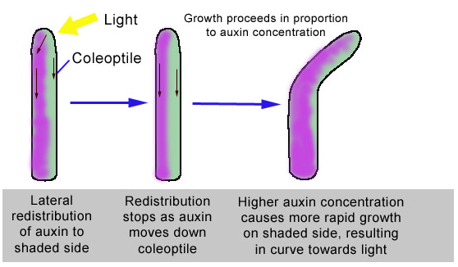

Grass seedlings have coleoptiles which respond to light under certain conditions. An experiment was set up in which different parts of coleoptiles were covered by a blindfold. Light could not reach any of the parts covered by a blindfold but could fall on uncovered parts of the coleoptiles. The different treatments were labelled A to G inclusive.
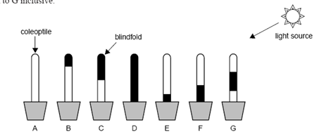

In which of the treatments shown would you expect to see a growth response to light?
A, E, F, G

Explain why you would expect to see this response in your choice above?
Auxins are produced in the tip of the coleoptile and migrate laterally away from light. The tips of these plants are still exposed to light; therefore the auxin will migrate to the shaded side of these plants, accumulate and cause elongation resulting in positive phototropism.

Define photoperiodism
An organism’s physiological response to the length of day or night.

What is the difference between long day and short day plants?
Long day plants require long periods of light before flowering. Short day plants refers to plants that require a long period of darkness before flowering.

Predict whether short day (long night) plants will flower under the following conditions

CONDITION | FLOWERING | EXPLANATION
Long day/short night | Will not occur | Insufficient length of uninterrupted darkness.
Short day/long night | Will occur | There has been a sufficient amount of uninterrupted darkness.
Short day/long night with a flash of light halfway through the night | Will not occur | Although there was a long period of darkness, this was interrupted by a brief period of light.

Predict whether long day (short night) plants will flower under the following conditions

CONDITION | FLOWERING | EXPLANATION
Long day/short night | Will occur | A sufficiently long period of light was provided.
Short day/long night | Will not occur | The length of the period of light was insufficient
Short day/long night with a flash of light halfway through the night | Will occur

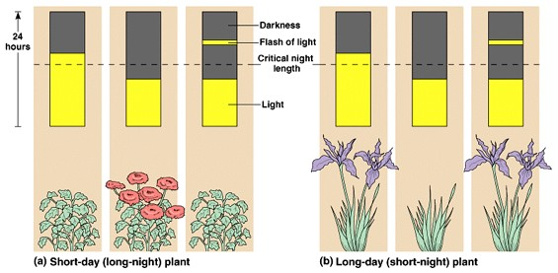

http://bcs.whfreeman.com/thelifewire/content/chp39/3902002.html

What is vernalisation?
The subjection of seeds or seedlings to low temperature in order to hasten plant development and flowering.

What is dormancy? Briefly explain the advantage of dormancy.
Dormancy refers to seeds or plants that stop growing when conditions are unfavourable. When plants are dormant their energy requirements are decreased. This enables the plant to survive until conditions become more favourable for growth to occur.

ADAPTATIONS
Nelson: 256-297
Biozone:

All organisms have structures and behaviours that improve their chance of survival in their natural environment. Those with the most favourable adaptations will have the greatest chance of survival

Define the term adaptation.
Refers to any physiological, structural of behavioural characteristic that enables organisms to maintain stability, obtain their requirements and increase their chance of survival.

Explain the difference between behavioural, structural and physiological adaptations.
Physiological adaptations refer to functions of the body that assist in the regulation of change.
Behavioural adaptations refer to conscious choices that are made that assist in the regulation of change.
Structural adaptations refer to structures of the body that assist in the regulation of change.

RHYTHMIC BEHAVIOURS
Nelson: 272 - 273
Biozone:
Many organisms have behaviours that occur at specific times or in specific patterns. These are governed by their interaction with other organisms or with the environment. These are called rhythmic behaviours.

What is a circadian rhythm?
Is a pattern of behaviour that occurs over a 24 hour period.

When do animals tend to be most active?
When the resources that they need in order to survive are most available.

Define the following terms and provide an example of an animal that would be active during each period

TERM | DEFINITION
Diurnal | These animals are most active during daylight e.g. cows
Nocturnal | These animals are most active at night e.g. bats
Crepuscular | These animals are most active either at dusk or dawn e.g. kangaroos

LIVING IN GROUPS
Nelson: 276 - 278
Biozone:

Some animals live solitary lives and only come together at certain times. Other animals live in groups. Identify 4 advantages of living in a social group.
Detecting predators: some species such as meerkats have sentries that keep a lookout for predators and warn others of their presence.

Safety in numbers: increasing the size of a group means that it is less likely that a specific individual will be taken by a predator. Predators are also less likely to attack large groups.

Raising young: if an entire group assists in the feeding and care of the young then those individuals are more likely to survive to maturity.

Obtaining food: some species of predators such as lions hunt in packs, increasing the chances of catching their prey. The food is shared increasing the chances of the group surviving.

What is a social hierarchy?
Some animals exert dominance over the others based on age or strength. For example in a group of elephants the oldest female or matriarch is dominant, whereas is a pack of gorillas it is the silverback (strongest male) that is dominant. Most members of these communities know their position in the group, but may seek to improve their position by challenging another organism higher up in the hierarchy.

COMMUNICATION
Nelson: 279 - 282
Biozone:
Explain the difference between signallers and signal receivers.
Signaller’s actions are detected by others who then modify their behaviour as a result.
Signal receivers receive signals and then alter their behaviour.

Animal communications generally fall into 3 categories; acoustic, chemical and visual.

Define each term and provide an example of each type of communication

METHOD | DEFINITION | EXAMPLE
Acoustic | This type of communication is audible (sound based). | Roosters make a clucking sound when food is available.
Visual | This type of communication is based on sight. Animals need to be able to see each other. | Gorillas expose their teeth as an aggressive sign
Chemical | These signals are odour (pheromone) based. They are usually detected by smell or similar | Animals such as tigers mark their territories by spraying structures with a mixture of urine and pheromones.

MIGRATION
Nelson: 287 - 290
Biozone:

Is migration a rhythmic behaviour? Explain.
Yes as it is an activity that occurs on a regular basis.

What factors influence migration?
Seasonal changes such as temperature.

Identify the 3 types of migration
Land, water and air.

COURTSHIP, REPRODUCTION AND PARENTING
Nelson: 291 - 297
Biozone:

Explain the significance of the following types of courtship behaviours

BEHAVIOUR | SIGNIFICANCE
Pheromone production | Females emit pheromones indicating that they are ready to mate. These pheromones attract potential mates.
Aggressive behaviour | The potential mates for a female will fight with the strongest winning, with the outcome of producing stronger, healthier offspring
Displays | Displays may be visual or vocal. A mate is selected on having the best call or the most attractive plumage.
Offerings | Males bring “presents” to the female such as food or attractive items e.g. male bower birds place blue objects into bowers in order to attract females.

Explain the consequences of the following types of parenting including the safety of the offspring and numbers of offspring produced.

BEHAVIOUR | CONSEQUENCE
No parenting | Some species e.g. turtles do not look after their offspring at all; they just lay eggs and leave them. Organisms that “parent” in this way try to ensure the survival of the species by producing large numbers of offspring as the majority of the offspring do not reach adulthood.
Short period of parenting | In some species, one parent, usually the mother spends a certain period of time teaching the young what it needs to know in order to survive, before getting the offspring to leave their territory. Usually low numbers of offspring are produced.
Group parenting | Some species live in large groups such as herds, packs or prides. In this case many of members of the group will contribute towards keeping the young safe until they mature. Multiple young can be produced by different mothers at the same time.
Long period of parenting | Some species look after their offspring for a long period of time. These offspring are likely to reach maturity and so the numbers of offspring produced are very low.

PLANT ADAPTATIONS
Nelson: NA
Biozone:

Identify 3 adaptations of fire resistant plants and explain how each enables the survival of the plant.
Epicormic buds
These are buds that are dormant underneath the bark. They are kept dormant by hormones secreted by actively growing shoots, but when these shoots are damaged, they stop secreting hormones and the dormant epicormic buds start to shoot.

Lignotubers
Lignotubers are starchy swellings of the root. They contain bud similar to the epicormic buds, but also contain substantial amounts of nutrients. This provides the plant with nutrients until the plant has produced enough leaves to be able to photosynthesise efficiently.

Seeds requiring fire for germination
Some plants such as the Mountain Ash (Eucalyptus regnans) produce seeds that will not germinate until they have been acted upon by fire.

What is the name used to describe plants adapted to arid conditions.
Xerophytes

Identify 3 adaptations of these types of plants and explain how each enables the survival of the plant.
They have a reduced surface area like thin leaves so less water loss occurs.
Protected stomata in pits or under hairs also decreasing water loss.
Some plants are succulents e.g. cacti. These plants are able to store water in their tissues so that it will be available when needed.

What is the name given to salt resistant plants?
Halophytes

Identify 3 adaptations of salt resistant plants and explain how each enables the survival of the plant
Increased salt tolerance. These plants can continue to function in higher salt concentrations than other plants.
Excrete salt from glands or leaves. These plants can eliminate salt before it reaches a concentration that will affect the plant.
Dropping salt-laden leaves. If the concentration of salt in a leaf becomes too high the leaf is dropped, preventing the salt from affecting the rest of the plant.

ECOSYSTEMS
Nelson: 301 - 305
Biozone:

What is ecology?
The study of the relationships between living organisms and their environment.

What is an ecosystem?
A self-sustaining environment that is made up of living organisms, their environment and the interactions between the biotic and abiotic factors.

What is the difference between a population and a community?
A population refers to members of the same species. A community refers to members of different species living in the same environment.

What are the 2 features of vegetation that are used to classify the name of an ecosystem?
The type of vegetation e.g. trees, grass etc. and the percentage cover.

INTERACTIONS BETWEEN LIVING ORGANISMS
Nelson: 309 - 318
Biozone:

All living organisms are directly or indirectly affected by each other.
Define the term “niche”
The role played by an organism.

There are specific terms to describe the role of each type of organism. Complete the following table, providing a definition of the role of each type of organism as well as 2 examples of each type.

ROLE | DEFINITION | EXAMPLES
Producer | Manufactures its own food by the process of photosynthesis | Plants
Consumers | Eat other producers or their remains | Horses, lions
Scavengers | Eat other producers or their remains | Hyenas
Decomposers | Break down organic material | Fungi, bacteria
Primary consumers (herbivores) | Eat producers (plants) | Cows
Detritovores | Eat small fragments of organic matter | Worms
Parasites | These live or on in another living organism and their presence is detrimental to the host | Ticks
Secondary consumers  (carnivores) | Animals that consume other animals | Snakes

What is competition?
Interaction between different organisms that require the same resources.

Complete the table below defining interspecies and intraspecies competition. Provide an example of each.

TYPE | DEFINITION | EXAMPLE
Interspecies competition | Competition between members of different species for the same resources. | Kangaroos and cows both consume grass.
Intraspecies competition | Competition between members of the same species for the same resources. | Trees of the same species growing close to each other will compete for light, water and nutrients.

What is symbiosis?
Symbiosis is the relationship between organisms of different species that interact with each other in order to survive.

Complete the table below defining the 3 types of symbiosis and providing an example of each.

TYPE | DEFINITION | EXAMPLE
Commensalism | One organism benefits and the other is unaffected. | Remoras are attached to sharks, they benefit as they are transported by the shark and eat leftovers. The shark is not affected.
Mutualism | Both organisms benefit from the relationship. | Bacteria are located in the gut of cows. The cows benefit because the bacteria produce cellulase that facilitate digestion. The bacteria benefit as they receive nutrients from the cows.
Parasitism | One organism benefits and the other is harmed (to a greater or lesser degree) | Mosquitoes biting humans, the mosquitoes gain a source of nutrients, the human host loses blood.

POPULATION DYNAMICS

Nelson: 322

Biozone:

Population dynamics involves studying the changes that occur in populations over a period of time. Ecologists study changes in population because all living things are interlinked and it helps to find out more about the ecosystem and identify things that may happen in the future.

Growth rate of a population is estimated using the following equation

Growth rate = (br + ir) – (dr + er)

What information is this equation referring to?
BR = birth rate
IR = immigration rate
DR= death rate
ER = emigration rate

DISTRIBUTION
Nelson: 323 - 324
Biozone:

What does the term distribution mean?
The location of a population within an ecosystem.

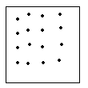
What type of distribution pattern is being shown in this diagram? Under what circumstances would this type of pattern be observed?
Uniform distribution: the organisms are evenly spaced. The position of one organism determines the location of the others. This pattern occurs when there are high density populations e.g. a rookery of penguins

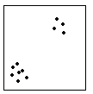
What type of distribution pattern is being shown in this diagram? Under what circumstances would this type of pattern be observed?
Clumped distribution: individuals are grouped together. This may be due to social behaviour such as fish forming schools, or it may be due to the location of resources.

What type of distribution pattern is being shown in this diagram? Under what circumstances would this type of pattern be observed?
Random distribution: there is no pattern to the location of organisms. Their positions are not dependent upon resources or the presence of other members of their species.

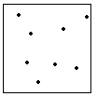

Observe the graph below
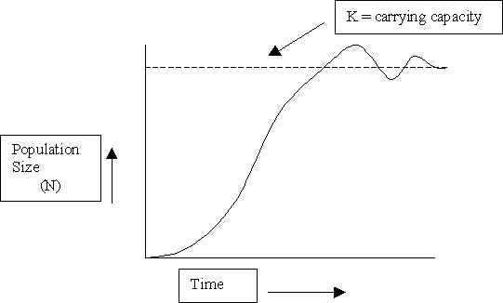
Stationary phase
Log phase
Lag phase

What information is being shown on this graph?
The effect of time on a population and that as long as conditions are relatively stable population numbers will fluctuate around the carrying capacity.

What does the term carrying capacity mean?
Carrying capacity is the maximum number of organisms that can be supported by an ecosystem. This is determined by the availability of resources that are required to support the population.

Why is the population fluctuating around K?
If there are no limiting factors then population numbers will continue to increase, however if the population rises above the carrying capacity then resources will limit further expansion as the organisms will compete for the limited supply of resources. If the population numbers decrease then there is less competition for resources and the population number can increase.

What is environmental resistance?
Environmental resistance refers to any factors in the environment that can have an effect upon a population e.g. food, water and shelter.

Identify the “lag” phase on your graph. Identify and explain what is happening to population numbers during this phase.
The lag phase refers to the initial period where population growth is slow. This occurs because when a species is introduced into an area there are only a few individuals that can reproduce.

Identify the “log” phase on your graph. Identify and explain what is happening to population numbers during this phase.
The log phase refers to the section of the graph where population growth is exponential. This occurs when there is no environmental resistance so the birth rate will exceed the death rate.

Identify the “stationary” phase on your graph and explain what is happening to population numbers during this phase.
This refers to the section of the graph where population numbers fluctuate around the carrying capacity. Environmental resistance affects population numbers; birth rate and death rate are approximately equal.

MEASURING POPULATION NUMBERS
Nelson: 326 - 328
Biozone:

Explain how population numbers can be determined using direct observation.
There are a number of methods. Physically counting the organisms may be done, but this is difficult to do for any species capable of movement. Aerial photos can be taken and then used to count the organisms present. More often sampling techniques are used. This involves counting a smaller section of the population that is used to represent the larger population.

What is a quadrat? How are quadrats used to determine the population numbers?
A quadrat is a portable frame use to mark off a small area of habitat, usually one square meter. These smaller areas are selected at random to act as samples for assessing the local distribution of plants or animals in an ecosystem.

In each quadrat either percentage cover or the number of individuals of each species are determined. Information regarding several quadrats is averaged and used to determine approximate information for the larger area of interest.

Describe how the capture-mark-recapture process works.
A sample of organisms are caught in such a way that they are not injured.
The organisms are then marked for example with paint and then released
At a later point a sample of organisms are caught and the number of marked individuals that have been recaptured are counted.

CONTROLLING POPULATIONS
Nelson: 331 - 332
Biozone:
Some populations have been designated as pests for various reasons. Identify 2 reasons that a species would be designated as a pest species.
Population explosion: a rapid increase in the numbers of one species at the expense of others.
Introduction of foreign species which frequently lack predators and outcompete native species for resources.

Populations are generally controlled using 3 different methods. Define each of these methods.

TERM | DEFINITION
Culling | Killing a certain percentage of the population.
Biological control | Use of living organisms to control the population numbers of other organisms.
Chemical control | The use of chemicals such as herbicides and pesticides to control the population numbers of pest species.

Identify the 4 types of organisms used for biological control.

Generalist feeders, specialised feeders, parasites, microbial organisms

Discuss a successful application of biological control in Australia.
The use of the cactoblastis moth to control the prickly pear cactus. The prickly pear was introduced into Australia in 1839 and by 1920 covered approximately 25million hectares of farm land. There were no native organisms that were able to control the numbers of this cactus. The cactoblastis moth was introduced and specifically targets the prickly pear cactus, it lays eggs in the fleshy part of the cacti and the caterpillars then eat the tissue of the plant reducing it to a gooey mess and eventually killing the plant.

Discuss an unsuccessful application of biological control in Australia.
Cane toads were introduced in Australia in 1935 in order to control the population of sugar cane beetles. Unfortunately the cane toads did nothing to control the numbers of these beetles and being a generalist feeder ate many other species. Cane toads breed very quickly and out competed many native species for food sources. Additionally they are poisonous and lack predators.

RESTORING POPULATIONS
Nelson: 333
Biozone:

Recently there has been an increased amount of effort at conserving different species. Identify 6 methods of restoring populations.

Translocation: moving an endangered species from one area to another.
Captive breeding programs
Studying plants and animals to try to work out what conditions best suit them.
Maintaining parks and reserves
Assigning conservation status e.g. threatened, endangered etc.
Habitat management

Identify 3 reasons why effort is put into saving species and restoring populations.
Ecological value: there is an interaction between all living organisms, if one species becomes extinct then all other species will be affected either directly or indirectly.

Practical value: humans utilise other organisms in a variety of ways such as for foods, medications or similar.

Aesthetic value: we value the opportunity to see animals, even if it is only in zoos or similar.

ENERGY IN ECOSYSTEMS
Nelson: 342 - 356
Biozone:

What is the original source of energy in an ecosystem?
Sunlight

How is radiant energy converted into chemical energy?
Photosynthesis

Approximately what percentage of visible light is used by plants?
Less than 10%

Define the following terms

TERM | DEFINITION
Autotroph | Living organisms that produce organic molecules by the processes of photosynthesis or chemosynthesis.
Primary productivity | The amount of organic material produced by photosynthesis.
Biomass | The dried mass of organic material

What is a food chain?
A series of organisms each dependent on the next as a source of food. Food chains show the flow of energy from one organism to the next.

Draw a simple food chain including 4 organisms

Grass Grasshopper Rat Snake
Trophic level 1 Trophic level 2 Trophic level 3 Trophic level 4

Alternative name
Producer Primary consumer Secondary consumer Tertiary consumer

What are trophic levels?
Trophic levels are feeding levels.

Add the trophic levels onto your food chain.

What do the arrows on a food chain represent?
The flow of energy

What rule is used to estimate how much energy from one level reaches the next?
The 10% rule

Provide 5 reasons why energy is lost at each stage in a food chain?
The organism that takes in energy also uses it in a variety of ways:
- For movement
- For synthesis of molecules
- For mechanical work e.g. muscle contraction
- For temperature regulation
- For growth and repair

What is the difference between a food chain and a food web?
A food chain only shows a single chain of organisms, a food web shows multiple food chains and the interactions between organisms.

Why are food webs used in preference to food chains?
Food webs are more stable than food chains and give a better reflection of reality.

What is the difference between a specialist feeder and a generalist feeder? Give an example of each.
Specialist feeders have a single food source e.g. koalas only eat eucalyptus leaves.
Generalist feeders have a variety of food sources e.g. eagles eat a range of organisms such as rabbits, rats, mice, smaller birds, fish etc.

Which organisms are most likely to become endangered, generalist or specialist feeders? Explain.
Specialist feeders. If their food source is removed then they will die out. If one food source for a generalist feeder is removed they can compensate and utilise other food sources.

ECOLOGICAL PYRAMIDS
Nelson: 357 - 359
Biozone:

Food webs and food chains are useful in seeing the energy pathways in an ecosystem, but they do not show how much energy is involved, the numbers of organisms involved, how much energy is being transferred between trophic levels or the actual biomass involved. We use a range of different pyramids to give more precise information.

The diagram below shows a numbers pyramid.

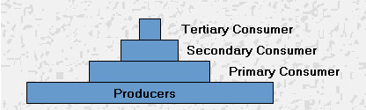

What information is shown on a numbers pyramid?
Shows the numbers of organisms in each trophic level.

What is the major limitation of numbers pyramids?
They don’t take the size/mass of the organism into account e.g. a tree and an insect both count as one individual.

The diagram below shows an energy pyramid

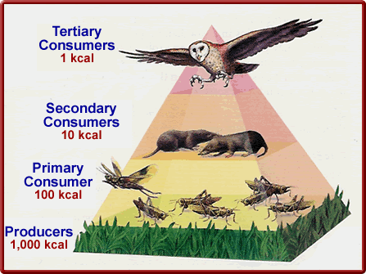
What information is shown on an energy pyramid?
The transfer of energy in a community of organisms

The diagram below shows a biomass pyramid

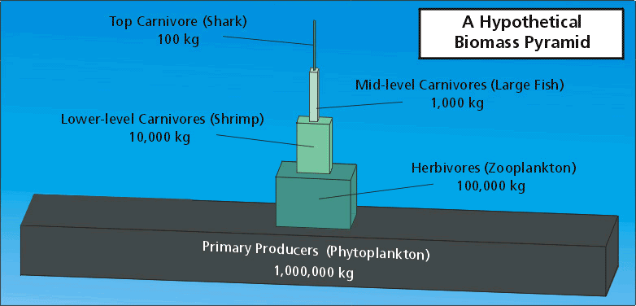

What information is shown by a biomass pyramid?
The total of dry mass at each trophic level.

Why is the removal of water important in this type of pyramid?
The majority of organisms contain a large percentage of water in their tissues, however, water is not a source of nutrients or energy. The removal of water gives a better indication of the amount of energy available.

Unlike some of the other “pyramids” this type of pyramid almost always has a pyramidal shape. Explain why.
The amount of biomass in each level should be greater than that in each successive layer. E.g. the biomass of plants has to be greater than the biomass of the herbivores, which is turn is greater than the biomass of the carnivores.

CYCLES IN ECOSYSTEMS
Nelson: 360 - 367
Biozone:
Unlike energy, matter is continuously cycling through ecosystems. The most important cycles for us are the carbon/oxygen, nitrogen and water cycles.

What does the term biogeochemical cycle mean?
Biogeochemical Cycles involve the transfer of matter from air, water and soil to the food chains and back again. The atoms are parts of different molecules at different types.

The diagram below shows the water cycle, label all of the processes shown.

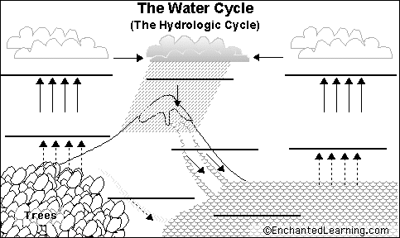
Accumulation
Infiltration
Run off
Precipitation
Transpiration
Evaporation
Condensation
Condensation

The diagram below shows the carbon/oxygen cycle. Identify all of the processes shown in this diagram.

Photosynthesis
Cellular respiration
Decay
Combustion

The diagram below shows the nitrogen cycle. Label all of the important chemicals and processes in this cycle.

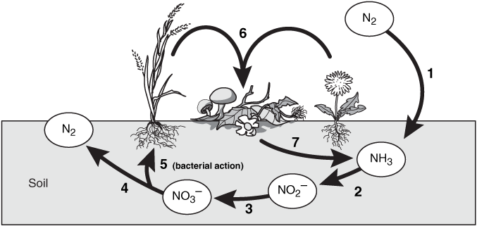

1: Nitrogen
2: Ammonia
3: Nitrite
4: Nitrate

Processes 1 to 3 are nitrogen fixing processes carried out by nitrifying bacteria. Nitrogen fixing involves unusable atmospheric nitrogen being converted into usable forms.
Process 4 is denitrification carried out by denitrifying bacteria. Nitrogenous compounds are converted back into nitrogen gas.
Process 6 is decomposition/decay

Why are bacteria important in the nitrogen cycle?
Bacteria are the only organisms that are capable of converting atmospheric nitrogen into nitrogenous compounds that can be used by other living organisms.

Explain why the nitrogen cycle is important to all living organsisms.
Nitrogen is a key atom present in nucleic acids and proteins. Both types of compound are essential to the life sustaining processes of all living organisms.

Observe the diagram below
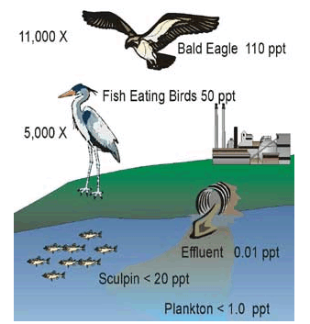
What is being shown in this diagram?
Biological accumulation

What do the different numbers on the diagram represent?
PPT on the diagram means parts per trillion. This represents the concentration of the chemical of concern.
The “X” indictates multiples. So it shows the multiplied concentration of the chemical in the

Explain why this effect occurs.
Biological accumulation (Biomagnification) is where the concentration of a substance increases as trophic level increases. The substance is present at a harmless level to start with. However, if the substance cannot be metabolised or excreted then it builds up in the fatty tissue of organisms. Each trophic level gets the effect of the dose accumulated in all of the lower levels of the food chain.

Which organisms are most affected by this? Explain
The top predators because they experience the cumulative effect from all of the lower levels of the food chain.

CHANGES TO ECOSYSTEMS OVER TIME
Nelson: 379 - 387
Biozone:
Ecosystems change over time. They undergo daily and seasonal changes as well as change over a greater period of time. We observe changes to help us work out what happened in the past, to help us learn about current trends and to predict what might happen in the future.

Identify 2 examples of long term change
Continental drift
Evolution

What is continental drift?
The gradual movement of the continents across the earth's surface over a long period of time

What is Pangaea?
The name used for the hypothetical original super continent which contained all of the current land masses.

Identify the 2 supercontinents that Pangaea split into.
Gondwana and Laurasia

Which supercontinent did Australia used to be part of?
Gondwana

What other continents/land masses were part of this supercontinent?
Africa, South America, India, New Zealand, Madagascar, numerous smaller islands.

What events caused Australia’s climate to change?
Australia moved north. Since Australia was no longer directly connected to Antarctica, Australia become both hotter and drier.

How has Australia’s changing climate affected the types of vegetation found in Australia?
While Australia was still connected to Antarctica the dominant form of vegetation was cool temperate rainforest. As the climate became hotter and drier the dominat form changed to sclerophyll (hard leafed) plants such as eucalypts.

SUCCESSION
Nelson: 388 - 390
Biozone:

What is succession?
A change in communities over a period of time.

What is the difference between primary and secondary succession?
Primary succession is the colonisation of plants in a new area. Secondary succession involves disturbance e.g. fire occuring in an area and plants later recolonise this area.

What is a pioneer plant?
Pioneer plants are the first plants to colonise new areas.

What is the purpose of pioneer plants?
They alter the conditions of the location so that other plants can colonise the area e.g. by breaking down rock or by adding nutrients to the soil.

What is a climax community?
The organisms that represent the end point of succession.

HUMAN INFLUENCE ON ECOSYSTEMS
Nelson: 400 - 414
Biozone:

What is habitat fragmentation, how does habitat fragmentation affect populations of flora and fauna?
Originally habitats were continuous, but when land is cleared, native habitats are reduced in size and are separated from each other.

Decreasing the size of native habitats decreases the number of native flora and fauna that can be supported rendering them more vulnerable to extinction. This is particularly the case for animals that require a large range in order to survive.

What is land degradation, how does land degradation affect populations of flora and fauna?
Land degradation is a reduction in the quality of the land as a result of misuse or overuse; for example the hard hooves of introduced animals make soil more compact limiting the ability of deep rooted native grasses to grow. Soil is more likely to be exposed and be blown away. Again the number of native flora and fauna that can be supported is significantly decreased.

Explain how dryland salinity occurs.
After it rains water may: Run off the surface and accumulate in bodies of water, be used up by trees and other plants or slowly soak into the soil until layers of rock or clay stop it from going further.

The water that soaks into the ground is known as groundwater and its upper surface is known as the water table. When the water table comes within 1.5 to 3 metres of the surface of the soil the salt rises to the surface by capillary action.

Trees act like pumps in the water cycle. They draw water from the soil through their roots. Some of the water is used up but some is evaporated through the leaves in the process of transpiration.

When the trees are removed the water is not used up and it accumulates as groundwater which means that the water table rises.

When the water table rises it brings salt into the area occupied by the roots of the trees and other plants.

Explain how dryland salinity contributes to erosion.
Saline (salty) water can also collect in depressions in the soil, dry out and leave a crusty saltpan behind. Few if any plants can survive in these conditions so they die out worsening the problem.

What is eutrophication, how does eutrophication affect populations of flora and fauna?
Eutrophication is nutrient enrichment: waters become rich in mineral and organic nutrients.

This promotes the proliferation of plant life, especially algae which then use up a greater amount of the dissolved oxygen.

This means that there is less oxygen available for the animals in the ecosystem, decreasing their numbers.

Identify 2 ways in which action is being taken to protect the environment.
Research into conditions that are conducive to the survival of species
Education programmes
Reclaiming damaged land
Protection of natural organisms and their environments

