Unit 3 outcome 2

Acetylcholine
Action potential
Allergen
Allergy
Antibody
antibiotics
Antidiuretic hormone(ADH)
Antigen
Apoptosis
Autoimmune disease
autocrine
Autonomic nervous system
Auxins
axon
Basophil
B-cell
bacteria
Cell-mediated immunity
chitin
Clotting
Connective neurone
Complement protein
Cytotoxic T cell
Cytokine
cytotoxins
Dendrite
Dormancy
Effector
Endocrine
Endoparasite
Ectoparasite
Exotoxin
Factor VIII
Fibrin
fungi
Fibrinogen
First messenger
Geotropism
Gibberellin
Glucagon
Growth regulator
Helper T Cell
Histamine
host
Homeostasis
Hormone
Humoral Immunity
Hypersensitivity
Hypothalamus
hypoglycaemic
interceptor
immune
Immunoglobulin
Immunosuppresent drugs
Inflammatory response
infectious
Insulin
Interferon
Intermediate host
innate
Killer T cell
Leukocytes
Lymphocyte
Lymphatic system
lysis
Mast cell
Macrophage
monocyte
Motor neurone
Memory cell
Mutualism
MHC
MHC restriction
Myelin sheath
Natural killer (NK) cell
Neuron
Neurotransmitter
Negative feedback
Non-specific defence mechanism
Non-self
neutrophil
Oedema
Parasite
paracrine
Pathogen
Phagocyte
Pheromone
Photoperiodism
Phototropism
Plasma cells
Platelets
protists
Positive feedback
Primary host
Prion
Receptor
Reflex arc
Rhesus factor
Resting potential
Respnse
resistance
Second messenger
self
Sensory neurone
Signal amplification
stimulus
Signal transduction
Signalling molecule
Specific immunity
synapse
Synaptic vesicle
Synaptic cleft
T-cell receptor
Thigmotropism
Toxin
Vaccination
Vector
Viroid
Virus

Why is homeostasis important for cell function?

Complete the following stimulus response in the shaded(blue boxes), use a word to describe what is happening. In each box state what is happening

What is a receptor?

What do the following receptors detect?
Chemoreceptor

Mechanoreceptors

Photoreceptors

Thermoreceptor

For each of the above receptors, name a location they would be found and what they would detect.

Match the definitions listed below.
- Hormones (endocrine signal)
- Neurotransmitter (paracrine signal)
- Cytokines (paracrine and autocrine)
- Neurohormones (between endocrine and paracrine)
- Pheromons
Definition
  - Neurons to the adjacent target cell
  - Neurosecretary cells secrete for targets near by but not adjacent
  - Secreterd by another organism
  - Secreted by and for the immune system
  - Is the target cell, as well as the signal producer
Endocrine system
What is a hormone?

What are the main organs/glands in the human body?

Chemical signals

Match the name to the definition

- Endocrine -
- Paracrine -
- Autocrine -

Definition
  - Target cell is next door
  - Is the target cell, as well as the signal producer
  - Target cell in another part of the body

What is the difference between positive and negative feedback?

Label the following diagram for the cell transduction
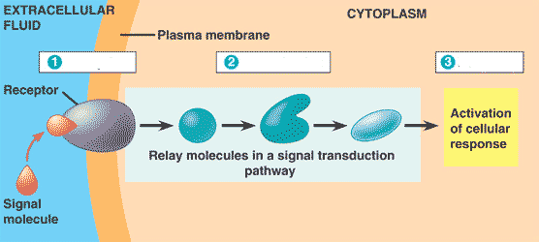
What kind of cellular response could this produce?

There are two types of hormones that produce signal transduction, what are they?

How are the two types of hormones different?

How is there transduction different?

What is a second messenger? Why is it important?

Use the following diagram to explain what would happen if there is high carbon dioxide levels in the body.

Show how blood glucose are maintained in the human body(high blood sugar and low blood sugars)

Plant hormones
Hormone | Effect
Auxin
Gibberellins
Cytokinins
Abscisic acid
ethylene

Plant responses
Response | Effect
Phototropism
Geotropism (negative)
Geotropism (positive)
photperiodism
heliotropism

Nervous system
Explain the nervous system role in the body

Complete the following diagram
Nervous system

Spinal cord

Brain

What is the difference between somatic and autonomic nervous system?

Label this diagram and name it.
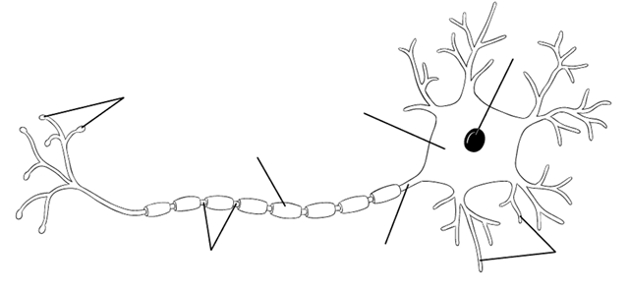

There are three types of neurons, name them, draw a diagram of each of the three types and explain their role in the body.

Label the following diagram
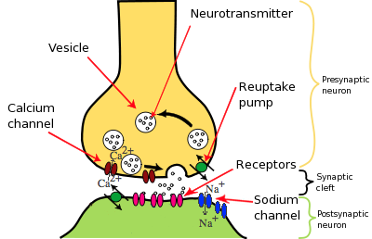

How does a nerve impulse travel through the body? Use the diagram below to help with your explanation.

Label each step
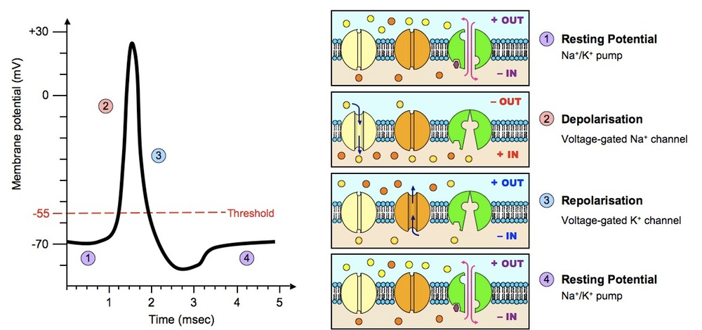
What is the role of the myelin sheath?

What happens if the myelin sheath isn’t working?

Draw a flow diagram to show the reflex arc

List three involuntary responses your body does.

Complete the following table
 | Reflex arc | Voluntary response | Involuntary response
Receptors involved
Transmission to CNS
CNS involved
Transmission from CNS

Immune system
What is a parasite?

What is a pathogen?

What is a disease?

What is our first line of defence?

Complete the table
Organism or agent | Structure | Mode of transmissiom | Disease example
Prion
Viroid
Virus
Bacteria
Fungi
Protozoa
worms

How do plants defend themselves?
Barriers
-
-
-
Secondary defence
-
-
-
-
-
Name the key components of the human immune system

What makes up the non-specific immune system?

What makes up the specific immune system?

How does the specific and non-specific immune system differ?

What is cytokine and why is it important?

What is an antibody?

What is an antigen?

Who makes antibodies?

What is MHC and how does it play a role in our immune system?

What is meant by a self -marker?

What is humoral immunity?

What is cell- mediated immunity?

Why do we have vaccines?

What is active immunity? And what are the two types? Explain the two types

What is passive immunity and what are the two types? Explain the two types

What is an autoimmune disease?

What is an allergy and how does it work in the body?

What is the rhesus factor and how does effect human life?

What is the inflammation response?

Why does our body form blood clots?

Why is the measles not as big an issue as they were 50 years ago?

Summary of the immune response
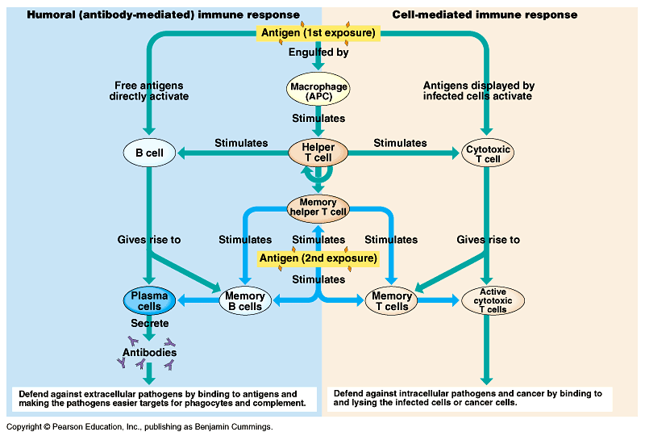

Complete the Venn diagram

